Greetings!

HOPE Animal-Assisted Crisis Response (HOPE AACR) members across the nation are participating in this year’s #GivingTuesday, a global day of giving fueled by the power of social media and collaboration. Every year this event falls on the Tuesday following American Thanksgiving, so that day of giving this year is November 28th, 2017.

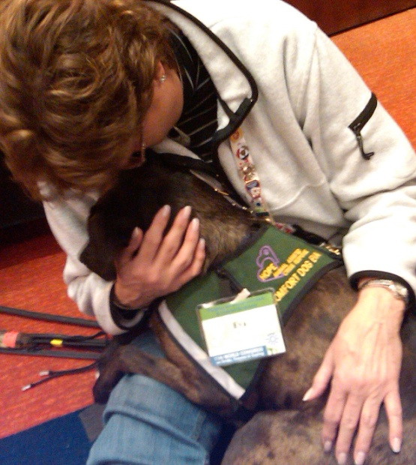
Funding will further HOPE AACR’s mission of providing comfort and encouragement through animal-assisted support to individuals affected by crises and disasters. This year has been an extremely active year as we have responded to a number of local and regional crises in addition to those of national significance, including California, Montana and Oregon wildfires, Hurricanes Harvey and Irma, and recent shootings.

HOPE AACR has been called a gem resource for businesses, schools, emergency management, and disaster volunteer organizations, as well as for members of the communities that have experienced traumatic events. Studies indicate animal-assisted therapy provides several beneficial physiological changes in the human body- increases in good hormones, lowering heart rate and blood pressure, etc.

We rely on the generosity of our teams and others who donate their time and money to our all-volunteer 501(c)3 organization. We ask you to please consider joining our members who live the passion of our mission with a donation to HOPE AACR.

Donating* is easy through a variety of methods:
- Website: http://hopeaacr.org/donate-to-hope/
- Facebook page: https://www.facebook.com/HopeAACR/
- Check mailed to: HOPE AACR, 1292 High Street, #182 ▪ Eugene ▪ OR ▪ 97401
* Your employer may have a program to match contributions

Thank you for your consideration and wishing you an extraordinary Holiday Season,
Hope Members from across the U.S. & Canada

