Instructions for editing the service history:
- Go the web site members only area and log in as you would normally
- Go to the service history tab and the year and type of event you want to add (call out, drill, event)
- At the bottom left, below the table, you should see the word edit - click on it (if you don’t see edit, your access level is not set correctly – contact webmaster@hopeaacr.org for this)
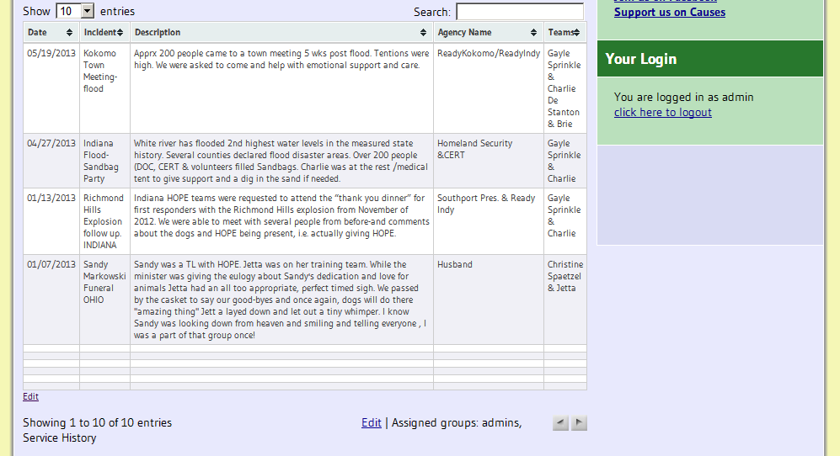
- Click the checkbox of the row below where you want your data entered (usually row 2)
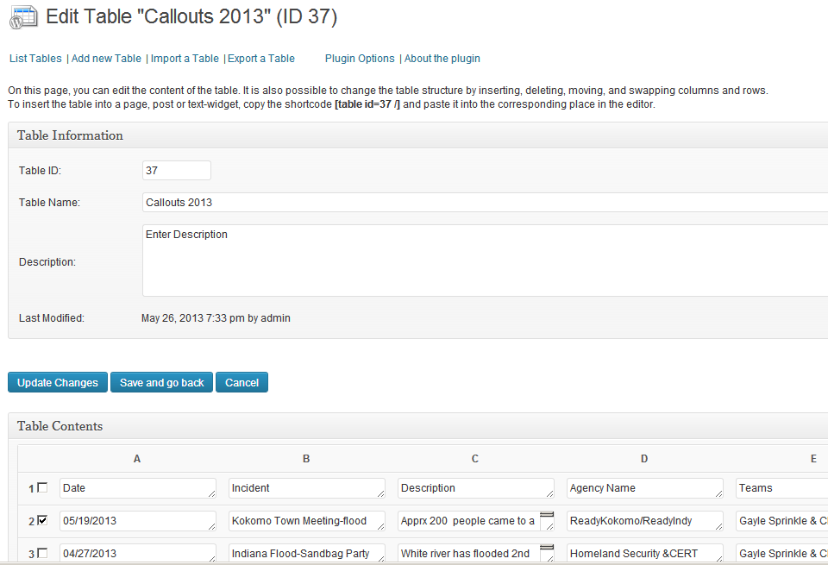
- Then go down to the Data Manipulation section and click insert row.
- Now fill in the added blank row and then click on "Update changes" to save your work. You can add multiple rows of data at a time.
- If the dates are out of order (should be newest first), you can use the sort tool to refresh the sort, and then click update changes again. Choose descending order.
- Notes on content:
  - When viewing on the web page, the row should not be more than 5 rows long. This should be a brief description of the event.
  - No personal information should be included about the individuals served.
  - No agency contact individual names should be listed or other AACR/AAT groups could use our work to get themselves called out.

