Denver Oct 2013 photos by American Red Cross

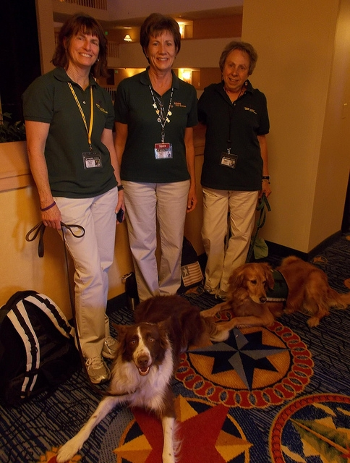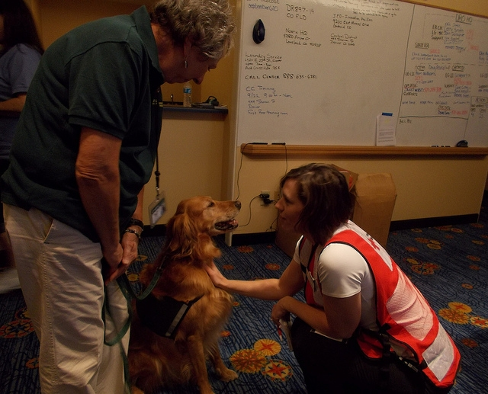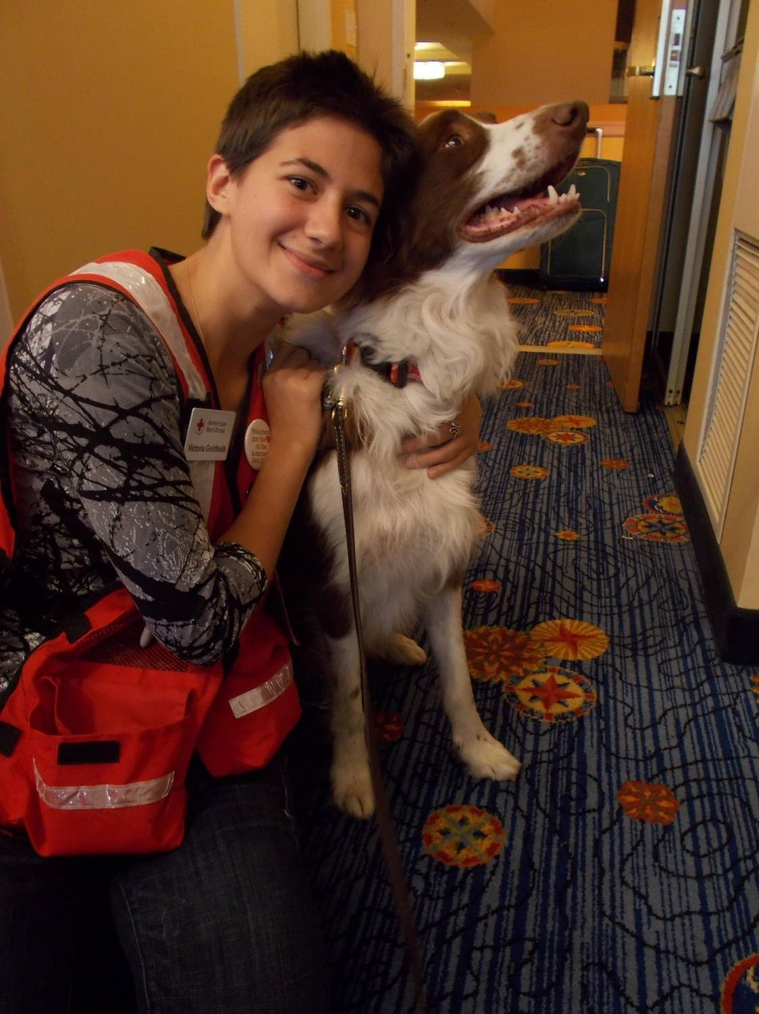
- Amy

Life has no remote. Get up and change it yourself!

----- Forwarded Message -----
From: "Scott, Jordan J." <jordan.scott@redcross.org>
To: "virginiaflyball@yahoo.com" <virginiaflyball@yahoo.com>
Cc: "lm22martin@hotmail.com" <lm22martin@hotmail.com>
Sent: Sunday, October 6, 2013 7:01 PM
Subject: RE: May we use photo?

Yes, please :) Glad you like the photo!

-Jordan

From: virginiaflyball@yahoo.com [mailto:virginiaflyball@yahoo.com]
Sent: Sunday, October 06, 2013 10:33 AM
To: Scott, Jordan J.
Cc: Scott, Jordan J.; lm22martin@hotmail.com
Subject: Re: May we use photo?

Jordan,

That's wonderful! It will be on our brochures. I will send you a copy when it gets finalized (probably a month or two).

Should it show copyright Red Cross?

Thx

- Amy

Sent from my iPad

On Oct 6, 2013, at 1:16 PM, "Scott, Jordan J." <jordan.scott@redcross.org> wrote:

Yes, please feel free. Where is it going to be used?

Jordan

Sent from my Samsung Galaxy Tab 10.1

Amy Rideout <virginiaflyball@yahoo.com> wrote:
Hello Jordan -

May we use the wonderful photo you shot of HOPE Dog Hondo and the Red Cross worker in Denver for our HOPE brochure?
http://www.flickr.com/photos/americanredcross/10039096196/in/photostream/

Of course, we would use the photo credit you have listed: "Photo Credit: American Red Cross/Jordan Scott" and can add a copyright if you want.

Thank you for the consideration!

- Amy

Life has no remote. Get up and change it yourself!

