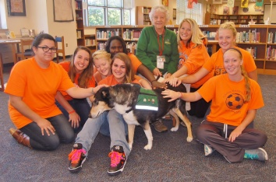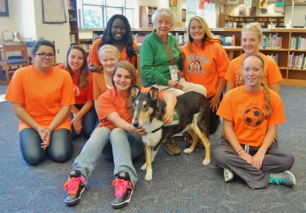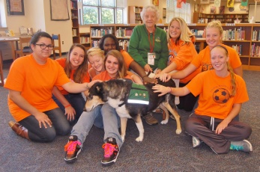
From: Brian Wallace
Sent: Wednesday, October 09, 2013 5:25 PM
To: janet@velenovsky.com
Subject: Re: Photos of Gail & Tani from Penn Manor

Thanks Janet. Please let us know if/when/where you use the photos.

-- Brian

Sent from my Verizon Wireless 4G LTE Smartphone

-------- Original message --------
From: Janet Velenovsky <janet@velenovsky.com>
Date: 10/08/2013 6:05 PM (GMT-05:00)
To: Brian Wallace <brian.wallace@pennmanor.net>
Subject: Re: Photos of Gail & Tani from Penn Manor

Received and appreciated!

Thanks. ::
Janet Velenovsky CPDT-KA, CDBC-TAC, KPA CTP, ACCBC

Sent from my iPhone

On Oct 8, 2013, at 1:09 PM, Brian Wallace <brian.wallace@pennmanor.net> wrote:

Hi, Janet:

You have permission to use the photos I sent you some time back of one of your guide dogs with Penn Manor High School students. Please credit Penn Manor School District if you publish the photos.

Sorry it took so long to get the approvals!

Please confirm that you received this email.

Thanks.

-- Brian

Brian Wallace
Community Relations Coordinator
Penn Manor School District
(717) 872-9500 xt. 2241
Cell: (717) 205-7838

From: Janet Velenovsky [mailto:janet@velenovsky.com]
Sent: Saturday, September 28, 2013 4:36 PM
To: Gail Thompson; Brian Wallace
Subject: Re: Photos of Gail & Tani from Penn Manor

Hi, Brian,

I am the Regional Director for the Eastern US for Hope AACR. Thank you for giving Gail the opportunities to be of service after the tragedy with the student there.

Our FB page is http://www.facebook.com/HopeAACR and our website is www.hopeaacr.org.

Please understand, it is perfectly understandable if families or the school do not wish us to share these photos for privacy reasons. Please do not feel it is necessary to press anyone for permission. But, if everyone involved approves them, we would enjoy sharing the photos.

Thank you again for letting Hope be a part of the healing process.

Best,

Janet Velenovsky, CPDT-KA, CDBC, KPA CTP, ACCBC
Eastern US Regional Director, Hope Animal-Assisted Crisis Response
facebook.com/HopeAACR :: www.hopeaacr.org

From: Gail Thompson
Sent: Saturday, September 28, 2013 1:40 PM
To: Janet Velenovsky
Subject: FW: Photos of Gail & Tani from Penn Manor

This is getting to be way over my head. I am not that computer literate! Can you respond to Brain directly?

Gail and Tani
717-581-3864
gailtdx@gmail.com

The key to Heaven was nailed to a cross! Have you found the key yet?

From: Brian Wallace [mailto:brian.wallace@pennmanor.net]
Sent: Saturday, September 28, 2013 12:28 PM
To: Gail Thompson
Subject: Re: Photos of Gail & Tani from Penn Manor

Hi Gail.

I don't think your use of the photos would be a problem. But I need to do a little research on this. Could you provide a link to the Facebook page, newsletter and website where they might be posted? I'll then check with our superintendent and give you a firm decision.

Thanks.

--Brian

On Sep 27, 2013, at 10:41 PM, "Gail Thompson" <gailtdx@gmail.com> wrote:

Brian…..

Janet, my District Director from HOPE sent me this email. I was told you would get the permission to use them, but can HOPE? …….as well as my tracking club put them in their monthly news? …..are there any limitations as to sending them to my friends?

Gail and Tani
717-581-3864
gailtdx@gmail.com

>>>>>>>>>>>>>>>>>>>>>>>>>>>>>>>>>>>>>>>>>>>>>>>>>>>>>>>>>>>>>>>>>>>>>>>>>>>>>>>>>>>>>>>>>>>>>>>>>>>>>>>>>>>>>>>>>>>>>

These are great. Do you have written permission to use them? I see the representative of the school sent them to you, but could you write and ask him if we can post the photos on Facebook and/or our web page? If he gives expressed permission, we might use them. (I am extra careful about kids.)

Thanks!

Janet Velenovsky, CPDT-KA, CDBC, KPA CTP, ACCBC
Owner, Kaizen Pet Training & Behavior
"Improve Your Pet, Improve Your Life" (TM)
804-883-1014 :: (home office, call first & leave message)
804-241-8405 :: (cell phone, poor/no signal at home)
janet@velenovsky.com :: velenovsky.com
facebook.com/kaizenpets :: twitter.com/kaizenpets
Eastern US Regional Director, Hope Animal-Assisted Crisis Response
facebook.com/HopeAACR :: www.hopeaacr.org

From: Brian Wallace [mailto:brian.wallace@pennmanor.net]
Sent: Friday, September 27, 2013 2:36 PM
To: gailtdx@gmail.com
Subject: Photos of Gail & Tani from Penn Manor

Hi, Gail:

I wanted to share these lovely photos of you, Tani and some of our students from your recent visit to Penn Manor High School.

Thank you so much for helping our students cope with the death of a classmate.

All the best.

-- Brian

Brian Wallace
Community Relations Coordinator
Penn Manor School District
(717) 872-9500 xt. 2241
Cell: (717) 205-7838

