Mary Martin
Rocky Mountain Regional Director Nominee
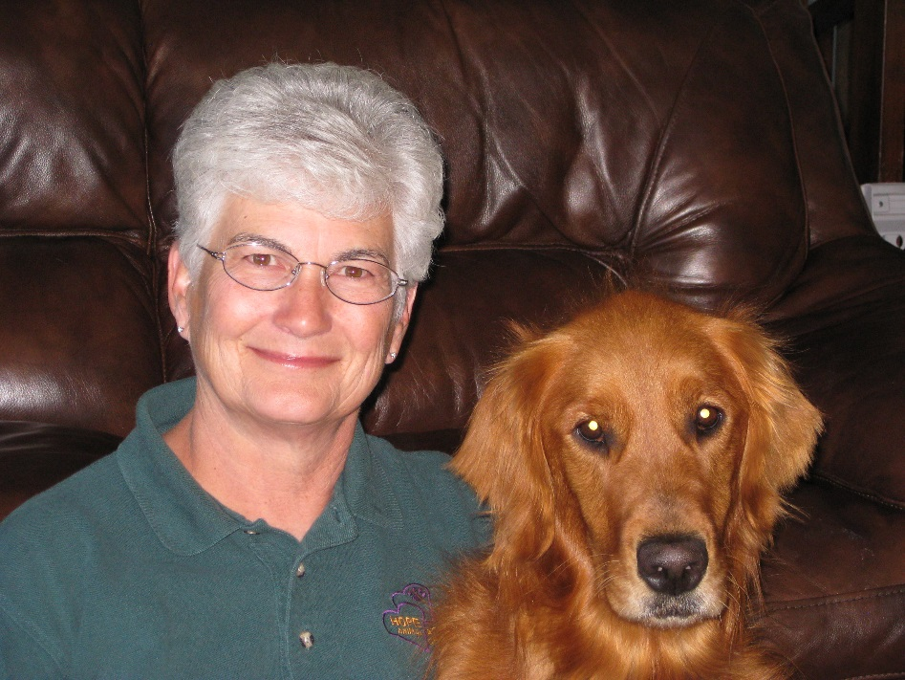
I
t was my DAD that instilled an idea of integrating my love of our dogs and helping people! When he could no longer relate to the world in general, he would often find a conduit back to reality with our dogs during his end stage dementia. So, it is with that thought, I will share a brief biographical sketch of my life’s journey to HOPE AACR today!

I attended Oregon State University and completed my student teaching at Thurston High School in Springfield, Oregon in 1973. Much later in 1998 this same school would experience one of our nation’s first school shootings and where Cindy Ehlers, HOPE AACR’s early founder, was asked to come in and help the students and staff through this tragic event with her dog Tikva!

I spent my teaching career (1973-2004) working in both Oregon and Montana with high school and elementary level students and their families. I continue to feel blessed to have had the opportunity and privilege of sharing many important and sometimes tragic events with those families.

After retiring in 2004, I began to reinvent what I might do with the next chapter in my life and was so fortunate to attend a HOPE AACR Open House in Bozeman, Montana. It was that opportunity that enabled me to blend my interest in working with my own dogs for the benefit of others and the training and experiences I had from my years as a public educator.

