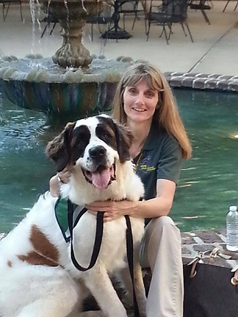

Cindy Becker
Regional Director
Southwest Region

My name is Cindy Becker, I live in North Carolina. I'm blessed with two daughters and six grandchildren.

I became a HOPE member in 2009 with my Rottweiler Uli. I certified Georgia,my Shih Tzu, in 2010 and in May 2015 certified Porsha my Saint Bernard.

I was appointed Acting Regional Director for the Southeast Region in 2012 then elected RD in 2013.

I sit on both the Education & Training and Finance Committees. I'm also on the Board for NCVOAD.

I look forward to serving HOPE AACR and the opportunity as RD to continue helping HOPE and the Southeast Region become a stronger organization.

