Janet Velenovsky, CPDT-KA, CDBC, KPA CTP, ACCBC
Eastern US Regional Director

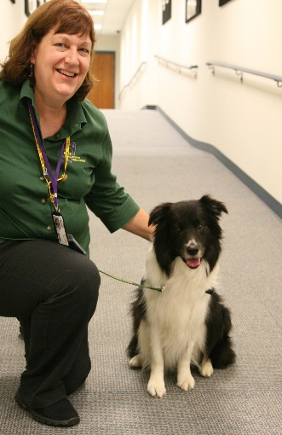

Hello, EUS Members! I have been a proud member of HOPE AACR for over 10 years now, and have served as Regional Director for the Eastern US for the past four years. During that time, our membership has almost doubled. We are experiencing significant growth in our region and our organization, and I am happy to be an active part of our development. With the incredible support of members within our region, EUS is the largest within HOPE at this time.

This year, we held two successful workshops in EUS in one year – the first time ever in the history of any region in HOPE.

My corporate background in both personnel and project management prepared me for running the region’s activities. My education and experience in canine behavior and training are valuable in working with our canine partners. I have participated in 18 HOPE workshops throughout all five regions, and have served in several roles within HOPE.

I would be pleased to continue my role as Regional Director. Goals for the EUS are controlled growth, development of leaders in each state, continued networking, and new opportunities to be of service.

