Julie Scott
Southwest Region
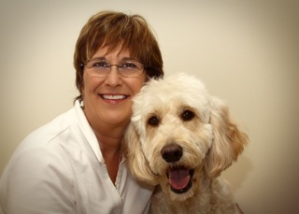

I’ve been a member of HOPE AACR, along with my canine partner, George since 2012, in Dade City, Florida. I have been the Florida area coordinator for over two years.
We’ve been a therapy dog team since 2010. Since that time, we have been volunteers at an elementary school as part of the READ program, with first graders reading to us; I started a program with the Dependency Court in Dade City, where registered therapy dogs bring comfort to children, families and others involved in the family court system; George and I also do AAT work with a pediatric speech pathologist at St. Joseph’s Hospital in Tampa.
In 2013, I assisted in organizing the SER workshop that was held in Dade City. I'm currently an almost retired family law/child advocate attorney, still conducting some family law and dependency mediations, as well as representing a few children as a guardian ad litem.
I would welcome an opportunity to serve as a Board member representing the SER as our organization grows and looks to the future.

