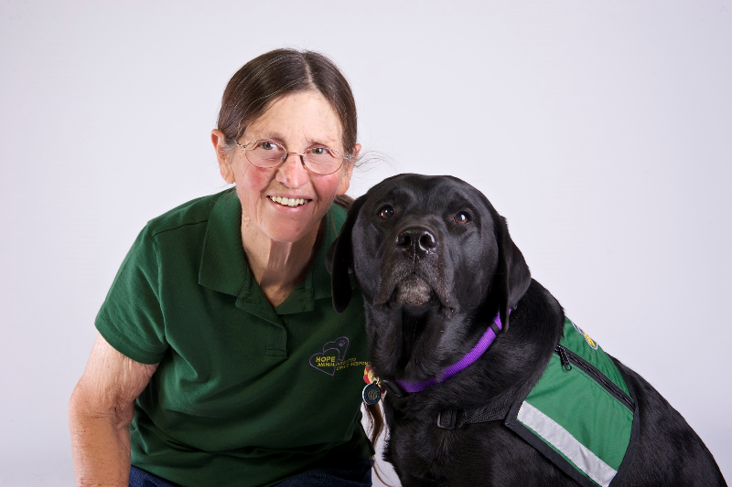
Kristie Bret Harte
Pacific Southwest Region

My name is Kristie Bret Harte. I have been a HOPE member since 2010 with my dog, Lily, and have been serving on the Board of Directors since 2013.
Lily and I began doing pet therapy in 2009 with the Bakersfield SPCA, and in 2010 became a registered team with Pet Partners. We visit in two hospitals and a skilled nursing facility, in conjunction with the hospice for which I have volunteered, first without then with a dog, since 2006.
My background is in teaching, primarily special education. I have been retired since 2005.
I have deep regard for HOPE and its mission. I consider it an honor not only to serve on the Board but to be part of this family who truly gives of itself professionally and with sensitivity and heartfelt compassion. The comfort provided by our members, human and canine, is immeasurable.

