Melanie Dunbar
Eastern US Region
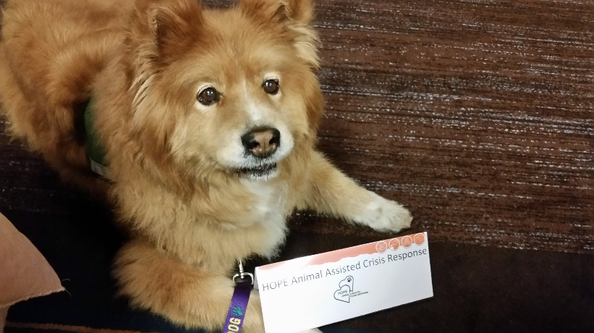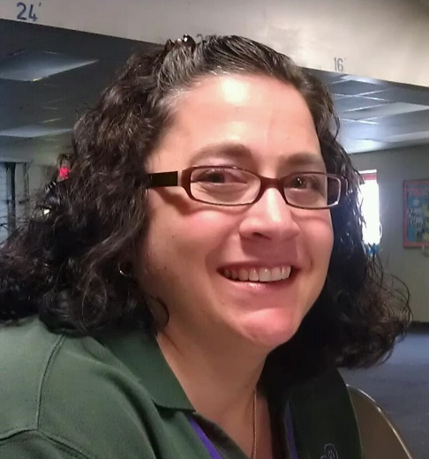
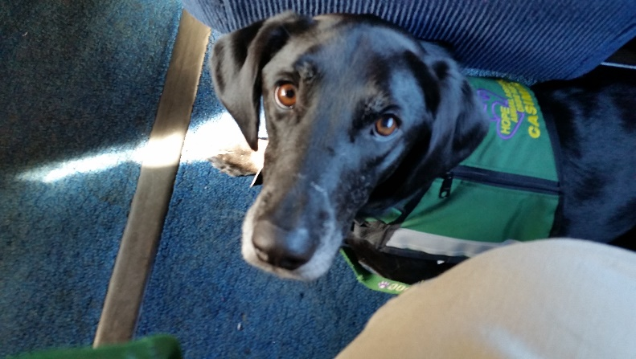

Hi! My name is Melanie Dunbar. As a nominee for the Board of Directors, I want to share a little about myself and my canine partners, Gus and Casimir (AKA Caz). I am a psychologist licensed professional counselor in private practice at The Family Institute in Erie, PA (where Gus has frequently been my co-therapist). I have six nephews and two nieces, all of whom I adore. I love reading and am a movie nut.
I adopted Gus, a golden retriever-chow mix in 2004 from a local rescue group (Because You Care) when he was 15 months old. Gus and I became registered with Therapy Dogs International in 2005 and began our work together. We work with a local hospice, mental health facilities, and several area nursing homes. In 2006, we became Delta Society Pet Partners. We are also registered with Alliance of Therapy Dogs. After encouragement from Yvonne Eaton-Stull, Gus and I were honored to join the ranks of HOPE AACR in August 2007. I adopted Caz through the same group at 10 months old in 2013. Caz has been registered since 2014 with Pet Partners and ATD, and we recently became certified with HOPE in May.
Gus’ favorite past time is mooching for treats, and Caz likes chasing or being chased, and agility. Both love playing with my parents’ dog next door. We have enjoyed both the opportunities we have been part of and the relationships we have developed through HOPE, and look forward to serving HOPE in the future and helping it grow.
I have represented EUS on the Board of Directors for the past four years and served as President since June 2012. I have been fortunate to be part of 12 workshops spanning all regions. I am co-chair of the Mental Health Committee which we brought into existence this past year. As President, I have worked to partner with other organizations on both the regional and national level. I have represented HOPE on the NVOAD Emotional and Spiritual Care Committee and at the NVOAD National Conference. I have sought to help our organization grow, geographically and numerically, to make us more able to respond. I am so excited this has definitely been happening!
My other core objectives as BOD rep and President are to incorporate all of the learning and experience we have gained into our processes, and to foster communication in the organization, especially with massive growth in numbers. I would love the chance to further our mission and utilize my experience through continued service on the Board of Directors. Thank You!

