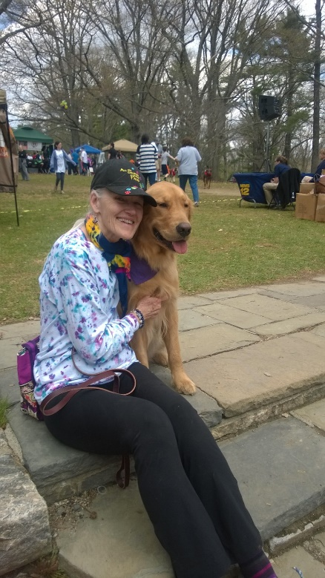
Kathe ODonnell

I began my journey of working to enhance the bond between people and animals when I and my Newfie, Maddie became certified as an animal assisted therapy team with the Delta Society Pet Partners program sixteen years ago.

From there I became a certified Delta Evaluator and Delta Instructor, received a graduate certificate in Animal Assisted Therapy and obtained an MS degree in grief counseling.

Parie my golden retriever, and I worked at the Family Assistance Center with the families of the victims of 911, and had been invited to participate in the many 911 memorials. Pare and I were one of the first AACR teams trained by Cindy Ehlers in 2002.

As a HOPE certified animal assisted crisis response team Parie and I spent many weeks working in New Orleans with the victims of Katrina.

I became an APLB (Association for Pet Loss and Bereavement) counselor in 2010, and presenter with that organization in 2012, and subsequent years.

After many years of loving service, Parie died in 2013. I am now sharing my life with my new golden, Shiloh, who is being trained for therapy and crisis response work.

